I have taken the amazon prime dataset and it has “show_id type title director cast country date_added release_year rating duration listed_in description” attributes in it.

EDA :

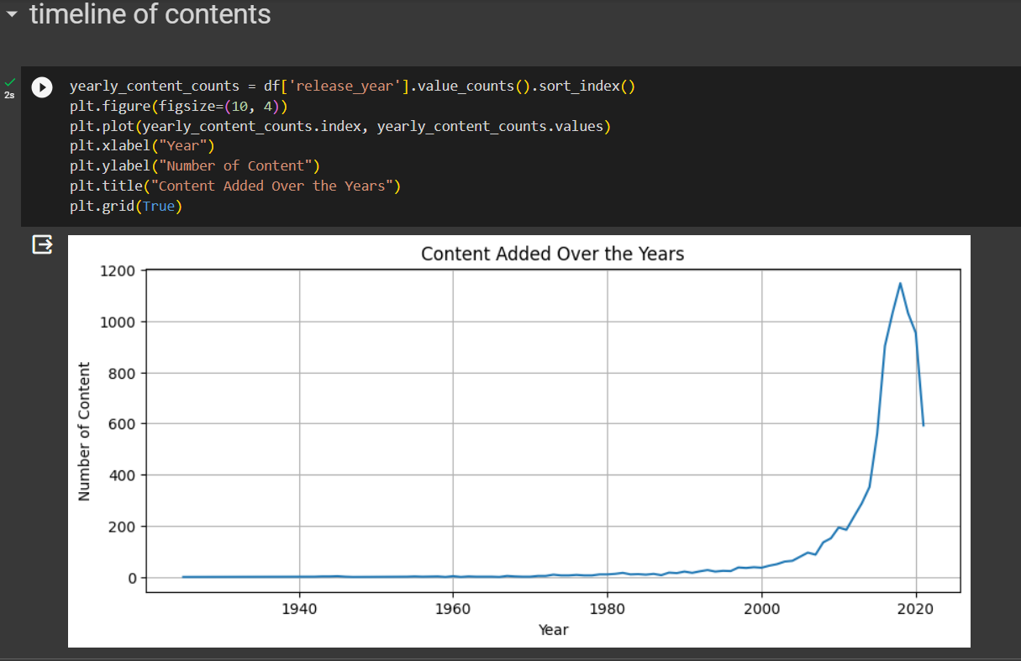

Insights : The number of content additions on Amazon Prime has been steadily increasing, with a noticeable surge in recent years.

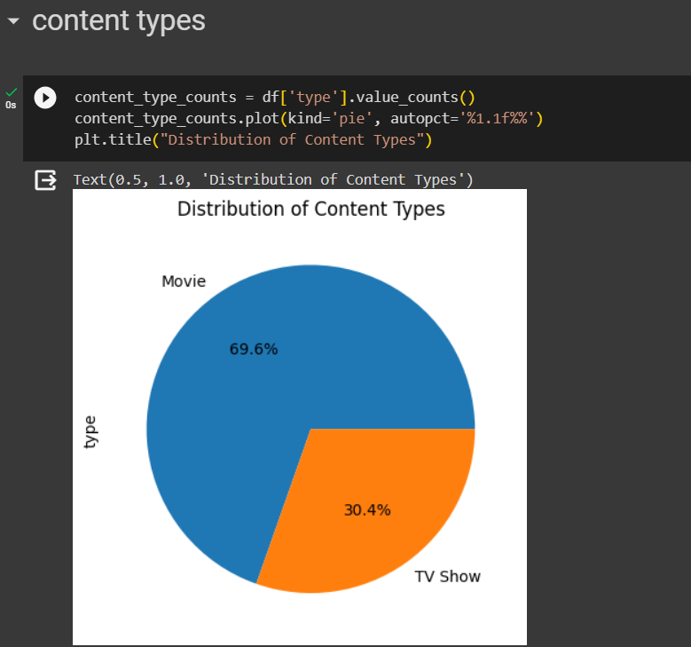

Insights : Movies constitute the majority of the catalog, accounting for 69.6% of the content, while TV Shows make up the rest.

Insights : The United States is the leading contributor to Amazon Prime's catalog, followed by India, the United Kingdom, and Canada.

Insights : The most prevalent genres in the catalog include International Movies, Dramas, Comedies, and Action & Adventure.

Insights : The number of content additions has grown consistently over the years, with a substantial increase from 2015 to 2021.